***Sieve of Eratosthenes***

Given a number n, print all primes smaller than or equal to n. It is also given that n is a small number.

**Example:**

***Input :****n =10*  
***Output :****2 3 5 7*

***Input :****n = 20*  
***Output:****2 3 5 7 11 13 17 19*

The sieve of Eratosthenes is one of the most efficient ways to find all primes smaller than n when n is smaller than 10 million or so.

Following is the algorithm to find all the prime numbers less than or equal to a given integer n by the Eratosthene’s method:   
When the algorithm terminates, all the numbers in the list that are not marked are prime.

**Explanation with Example:**

Let us take an example when n = 50. So we need to print all prime numbers smaller than or equal to 50.

We create a list of all numbers from 2 to 50.

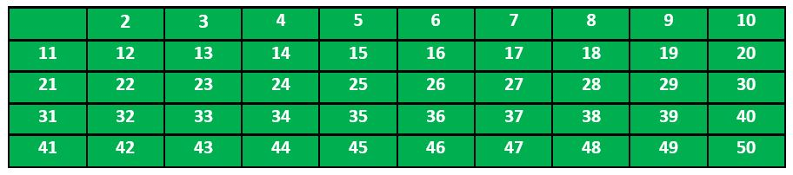

According to the algorithm we will mark all the numbers which are divisible by 2 and are greater than or equal to the square of it.

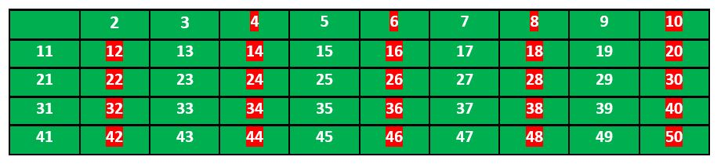

Now we move to our next unmarked number 3 and mark all the numbers which are multiples of 3 and are greater than or equal to the square of it.

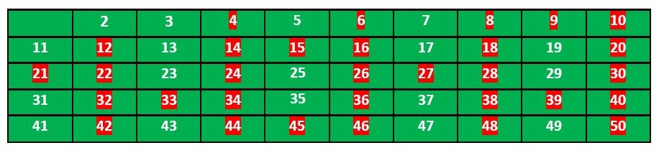

We move to our next unmarked number 5 and mark all multiples of 5 and are greater than or equal to the square of it.

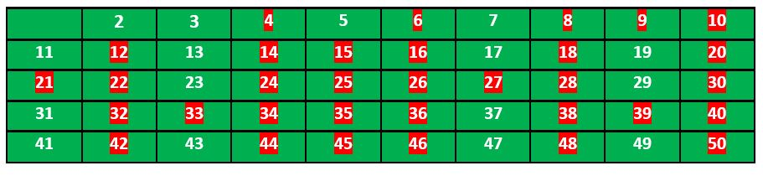

We continue this process and our final table will look like below:

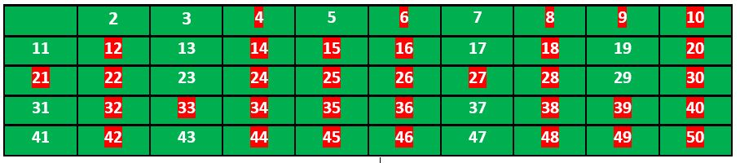

So the prime numbers are the unmarked ones: 2,3, 5, 7, 11, 13, 17, 19, 23, 29, 31, 37, 41, 43, 47.

**Implementation:**

Following is the implementation of the above algorithm. In the following implementation, a boolean array arr[] of size n is used to mark multiples of prime numbers.

C++Java

// Java program to print all primes smaller than or equal to

// n using Sieve of Eratosthenes

class SieveOfEratosthenes {

void sieveOfEratosthenes(int n)

{

// Create a boolean array "prime[0..n]" and

// initialize all entries it as true. A value in

// prime[i] will finally be false if i is Not a

// prime, else true.

boolean prime[] = new boolean[n + 1];

for (int i = 0; i <= n; i++)

prime[i] = true;

for (int p = 2; p * p <= n; p++) {

// If prime[p] is not changed, then it is a

// prime

if (prime[p] == true) {

// Update all multiples of p greater than or

// equal to the square of it numbers which

// are multiple of p and are less than p^2

// are already been marked.

for (int i = p * p; i <= n; i += p)

prime[i] = false;

}

}

// Print all prime numbers

for (int i = 2; i <= n; i++) {

if (prime[i] == true)

System.out.print(i + " ");

}

}

// Driver Code

public static void main(String args[])

{

int n = 30;

System.out.print("Following are the prime numbers ");

System.out.println("smaller than or equal to " + n);

SieveOfEratosthenes g = new SieveOfEratosthenes();

g.sieveOfEratosthenes(n);

}

}

**Output**

**Following are the prime numbers smaller than or equal to 30**

**2 3 5 7 11 13 17 19 23 29**

**Time Complexity:**O(n*log(log(n)))  
**Auxiliary Space:**O(n)